**Shreya Sapkal**

**Period 5**

**Big Idea #2 MCQ Practice Blog**



1. **Q19 Filtering and sorting restaurant data**

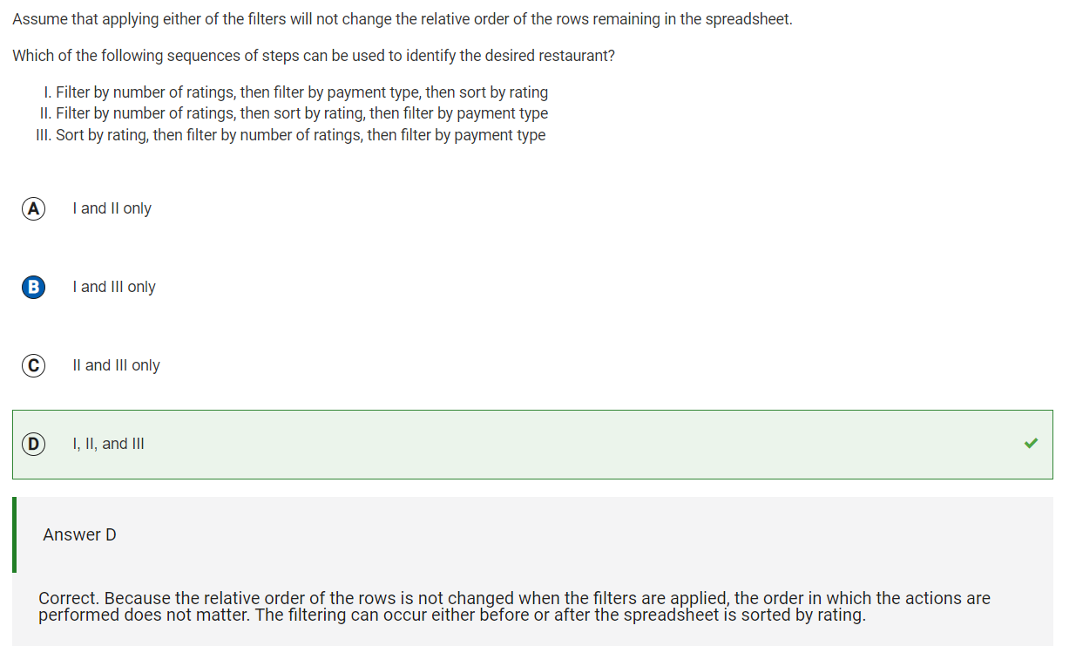

Reflection: This is the only problem that I got wrong in this MCQ problem set. I learned that the order in which these actions are taken does not matter, since the same thing is done in the end. Whether the sorting is done at the beginning or end doesn’t matter, because the correct factors are filtered out.

1. **Q1 Number of bits needed for item inventory**

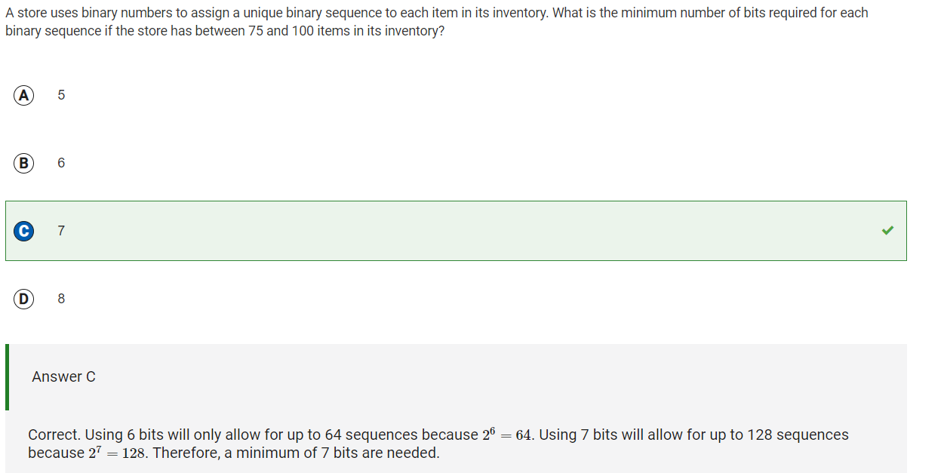

Reflection: I learned how to solve problems using bits from this question. I looked at the biggest number given in the range (100), and then found the smallest power of 2 which could get me above 100, and I got 7, because 27 = 128.

1. **Q25 Effect of appending three zeros to a binary number**

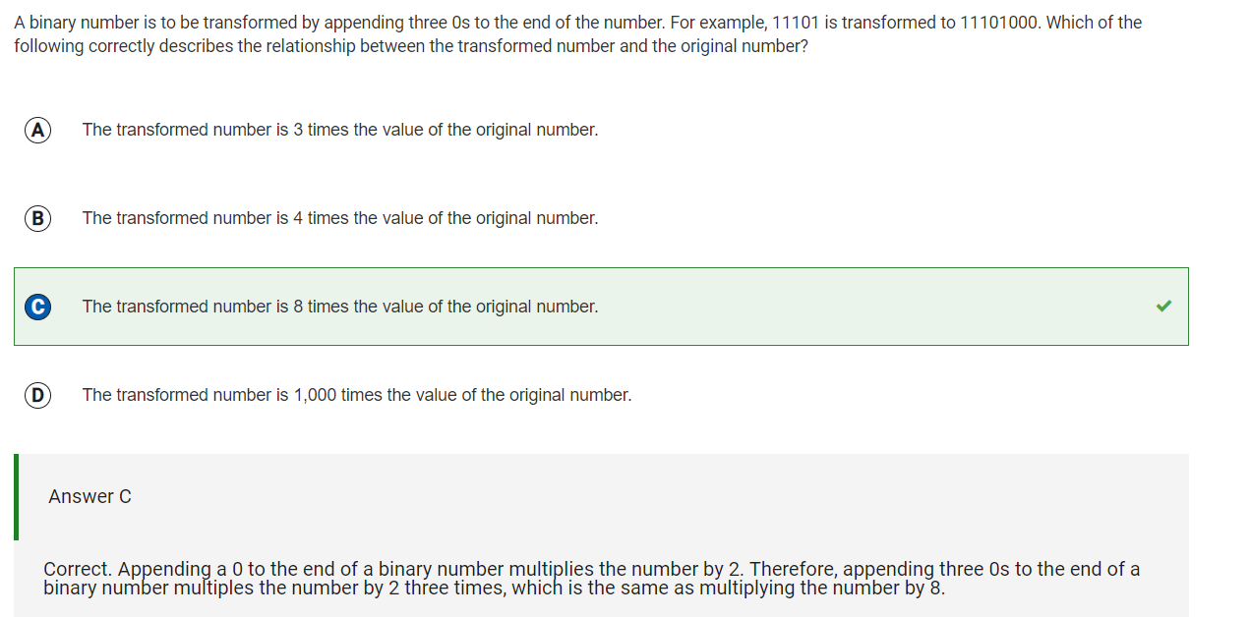

Reflection: From this problem, I learned that by appending a 0 to the end of a binary number, you multiply the number by 2. Following this pattern, if you add 3 zeros to the end of a binary number, you are multiplying it by two three times (2^3), and therefore you are increasing the value of the original number x8.